DNS configuration
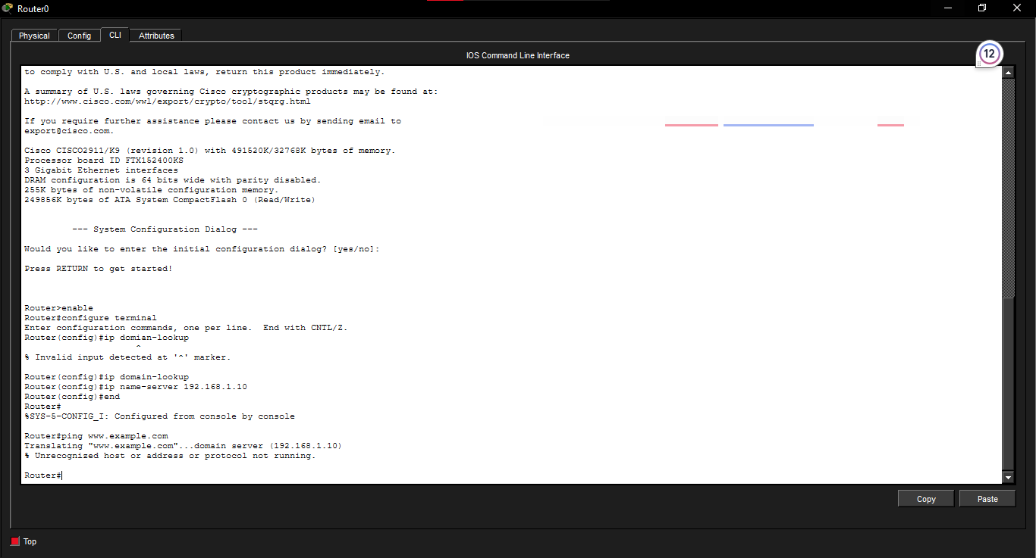

Clearing ARP cache

Show ARP
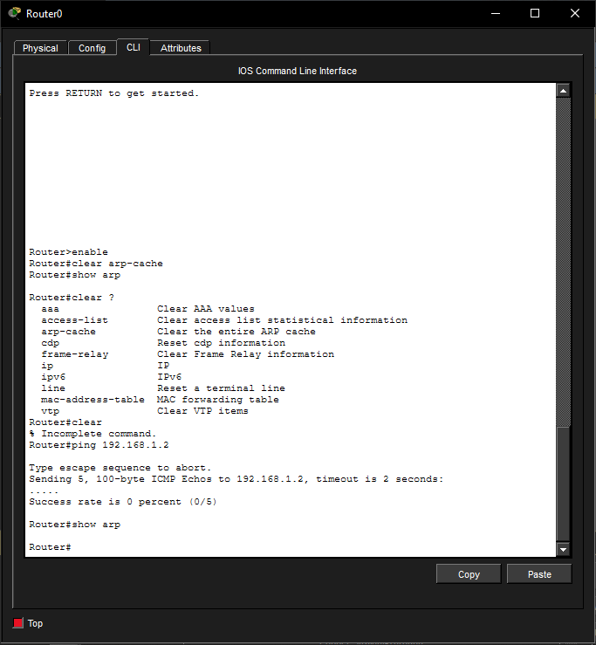

Reflection Questions
20. An ARP entry connects an IPv4 address to a MAC address, within the network. A routing table shows the destination network, the hop or the exit interface and how the data should be sent. It usually does not include the MAC address of the neighbor that's the final destination.
21. The routing table shows where the packet needs to go but Ethernet delivery needs a destination MAC address. ARP takes the next-hop IPv4 address. Finds its MAC address so the router can create the outgoing frame.

